Line Graphs-Answers
Key Stage3: 2003 Paper1 Level 3-5
1.
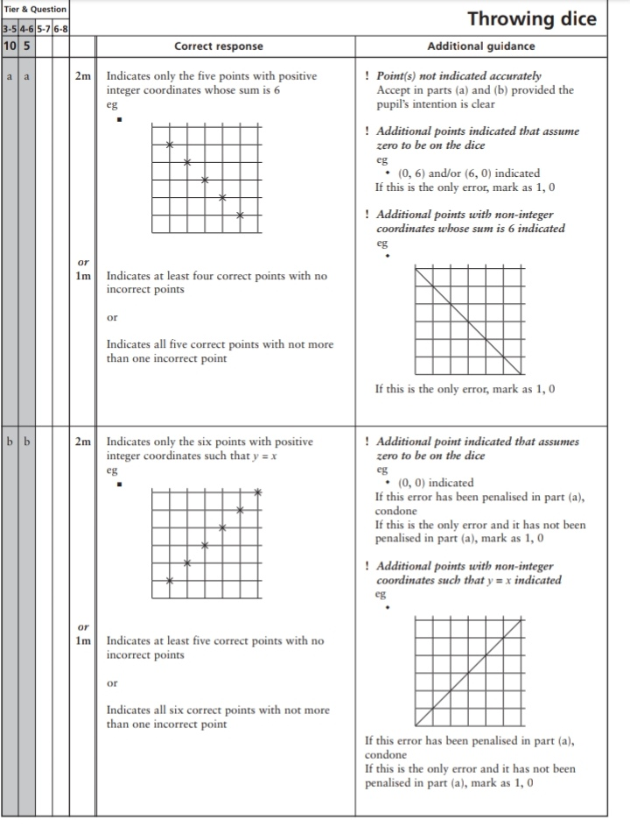
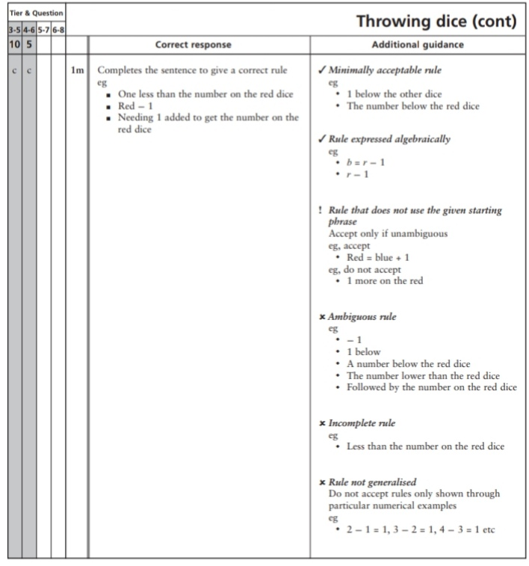
Key Stage 3: 2004 Paper 1 Level 3-5
2.
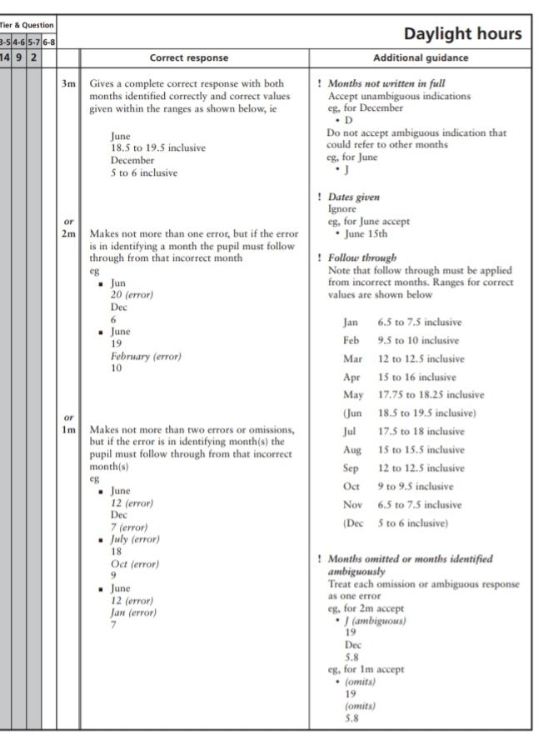
Key Stage 3: 2004 Paper 1 Level 4-6
3.
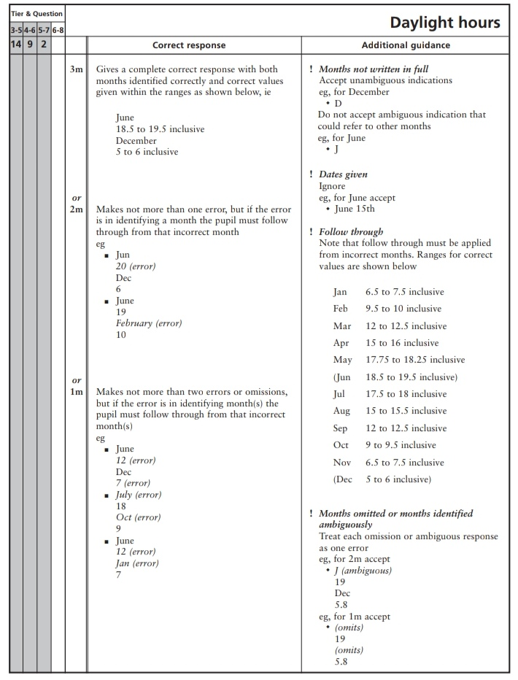
Key Stage 3: 2005 Paper 2 Level 3-5
4.
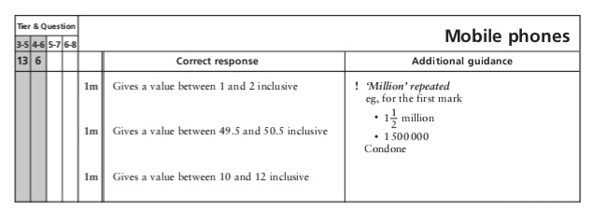
Key Stage 3: 2005 Paper 2 Level 4-6
5.
